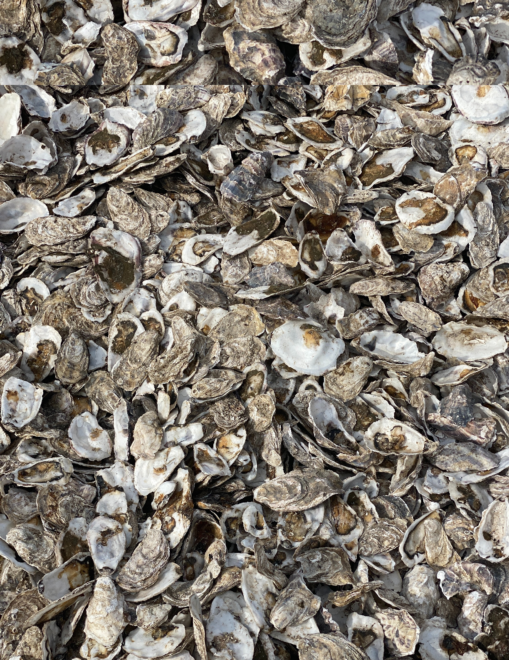

Oyster Data
We continue to monitor and evaluate SOPS ability. Oyster growth data was collected in 2022 – 2023, which suggested that the rotation provided by SOPS increased survivability compared to static cages of spat on shell. Survivorship of triploid seed was also high. Condition indexing was done on oysters grown on SOPS that showed robust meat growth and deeper cups, traits that make for a more marketable oyster. This is encouraging considering these oysters were grown in Baltimore Harbor, which has poorer water quality compared to most oyster farms. We look forward to continuing to track SOPS performance in 2024 as we test the SOPS prototype on an active oyster aquaculture farm in Fishing Bay, Maryland.
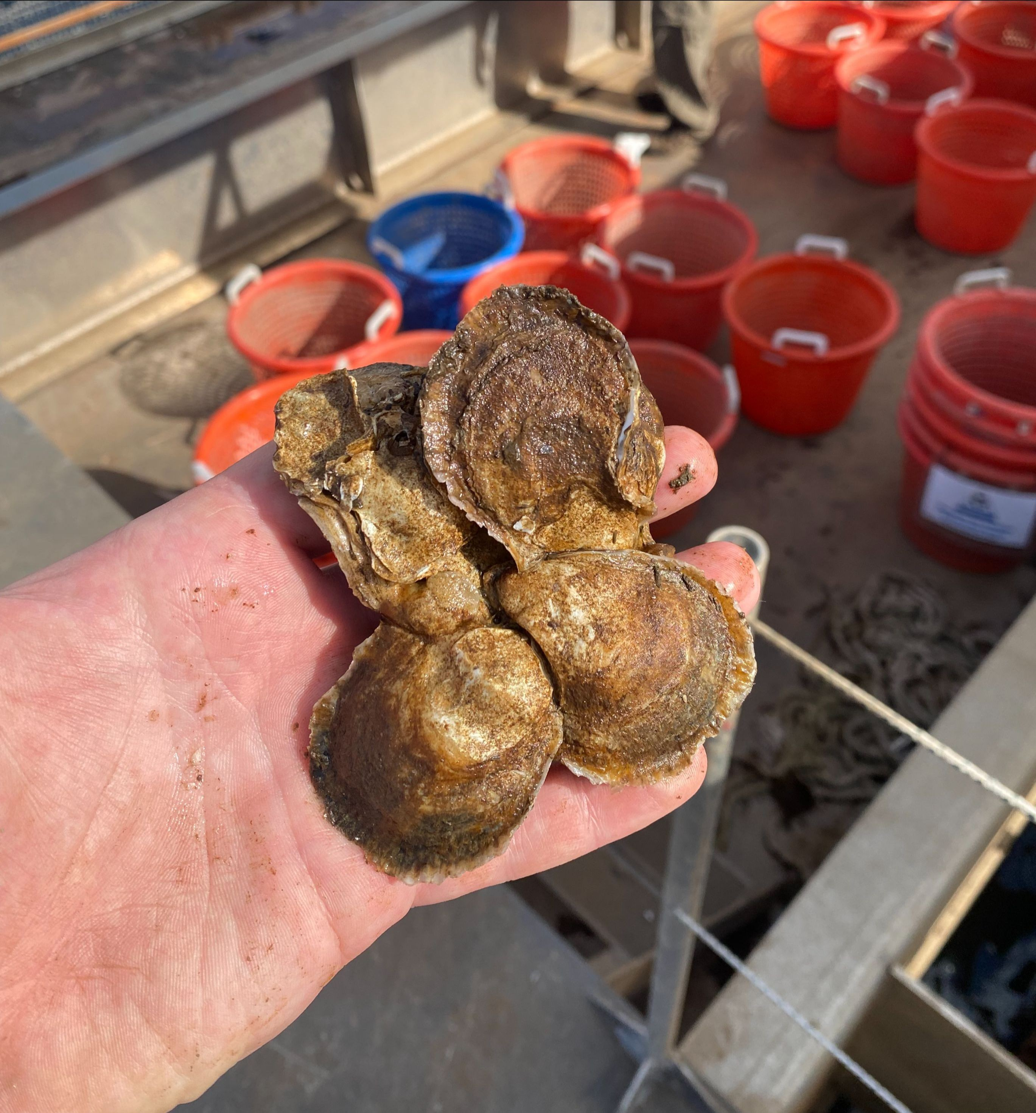
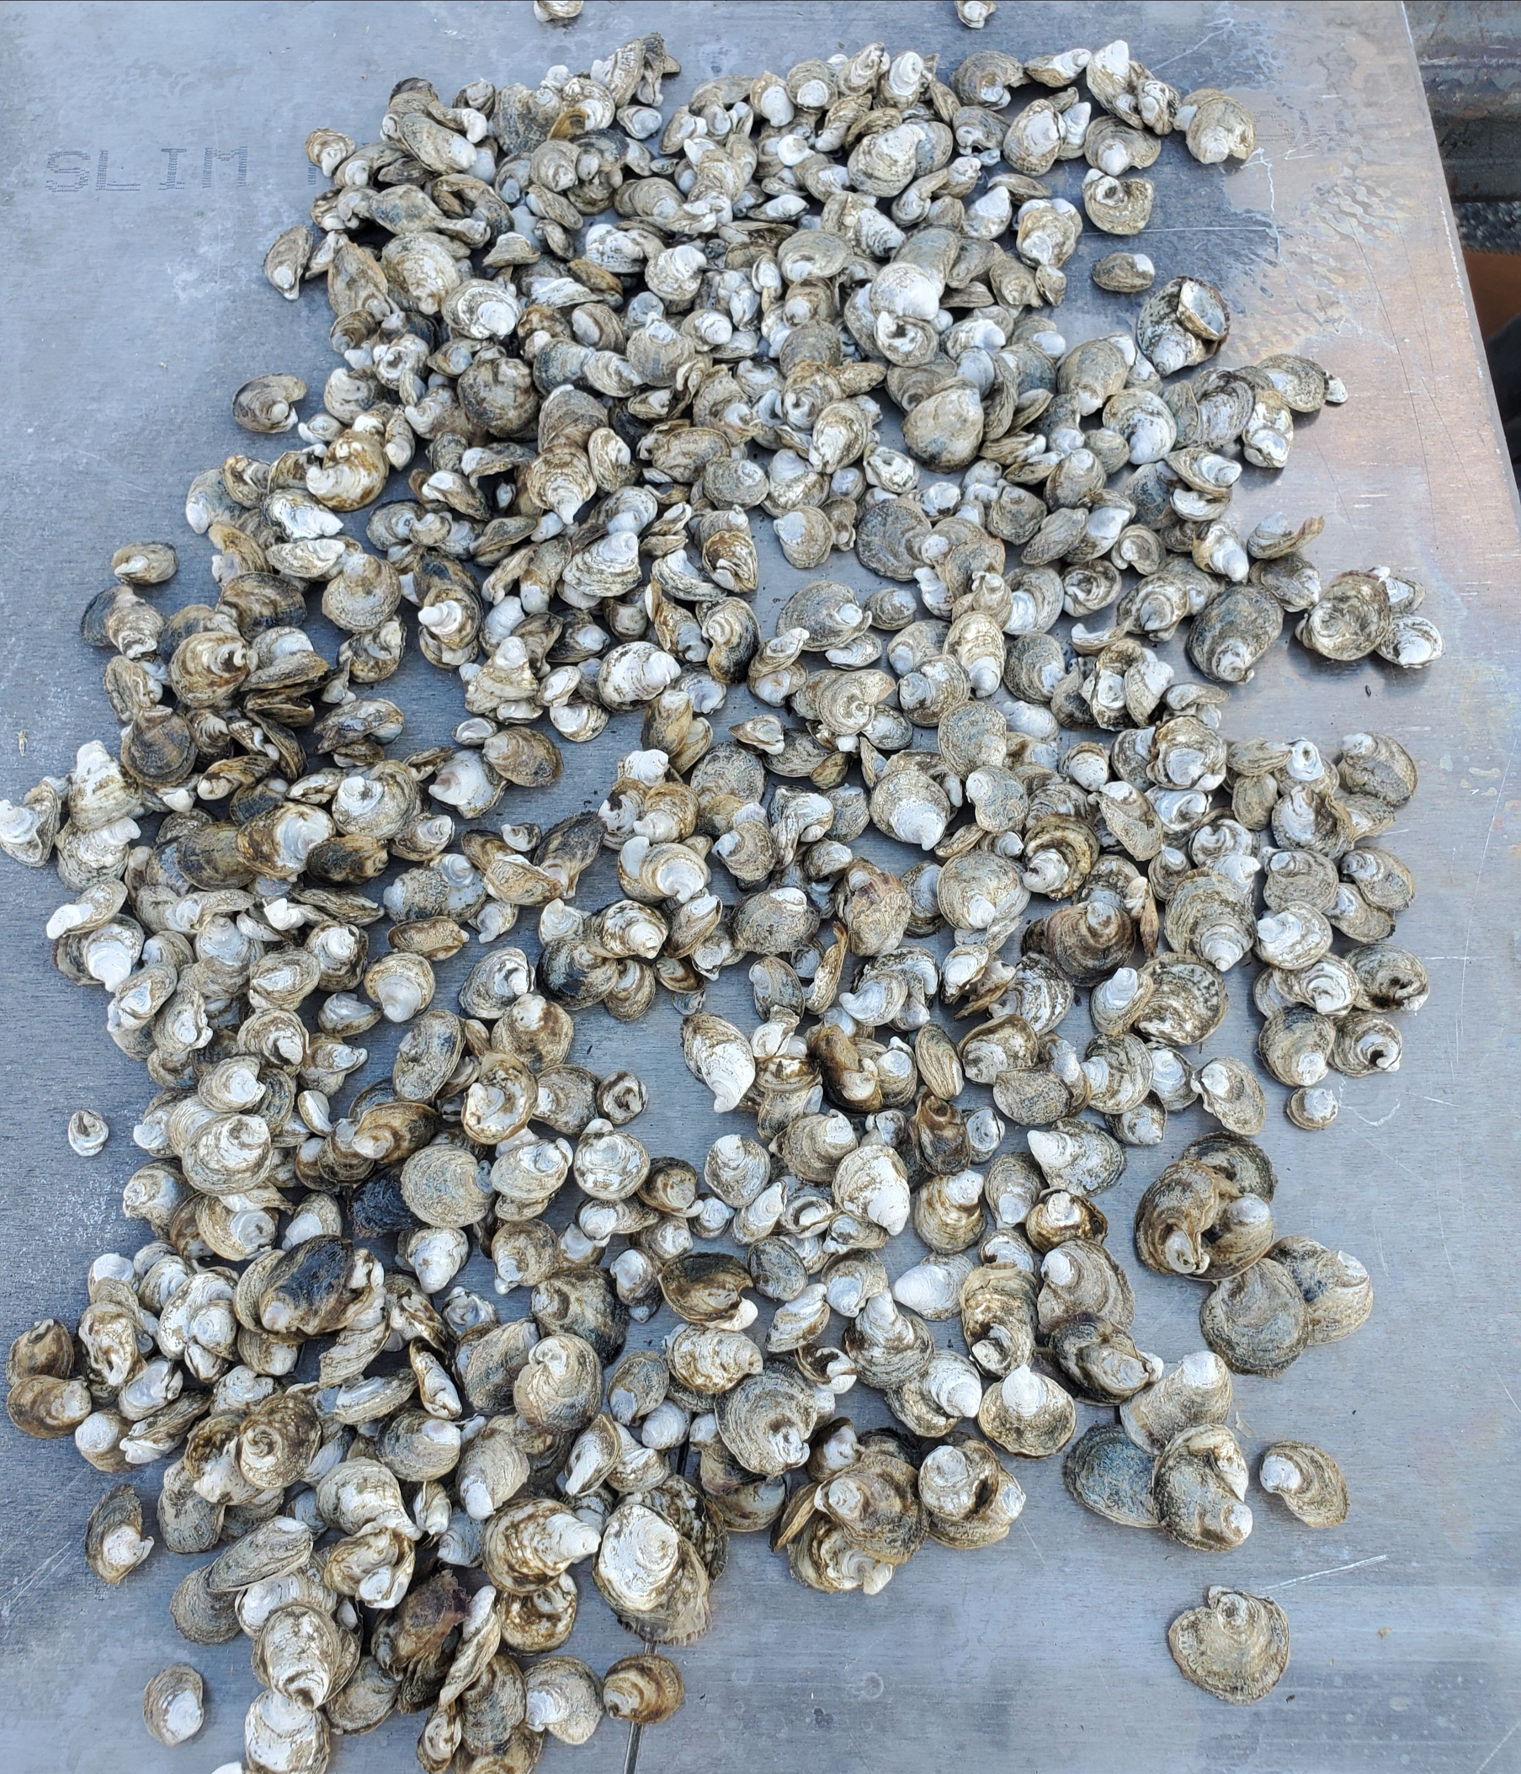
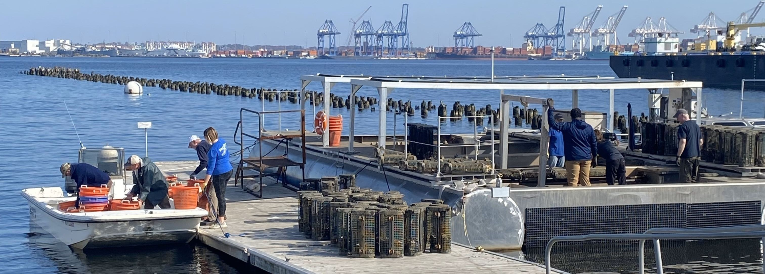

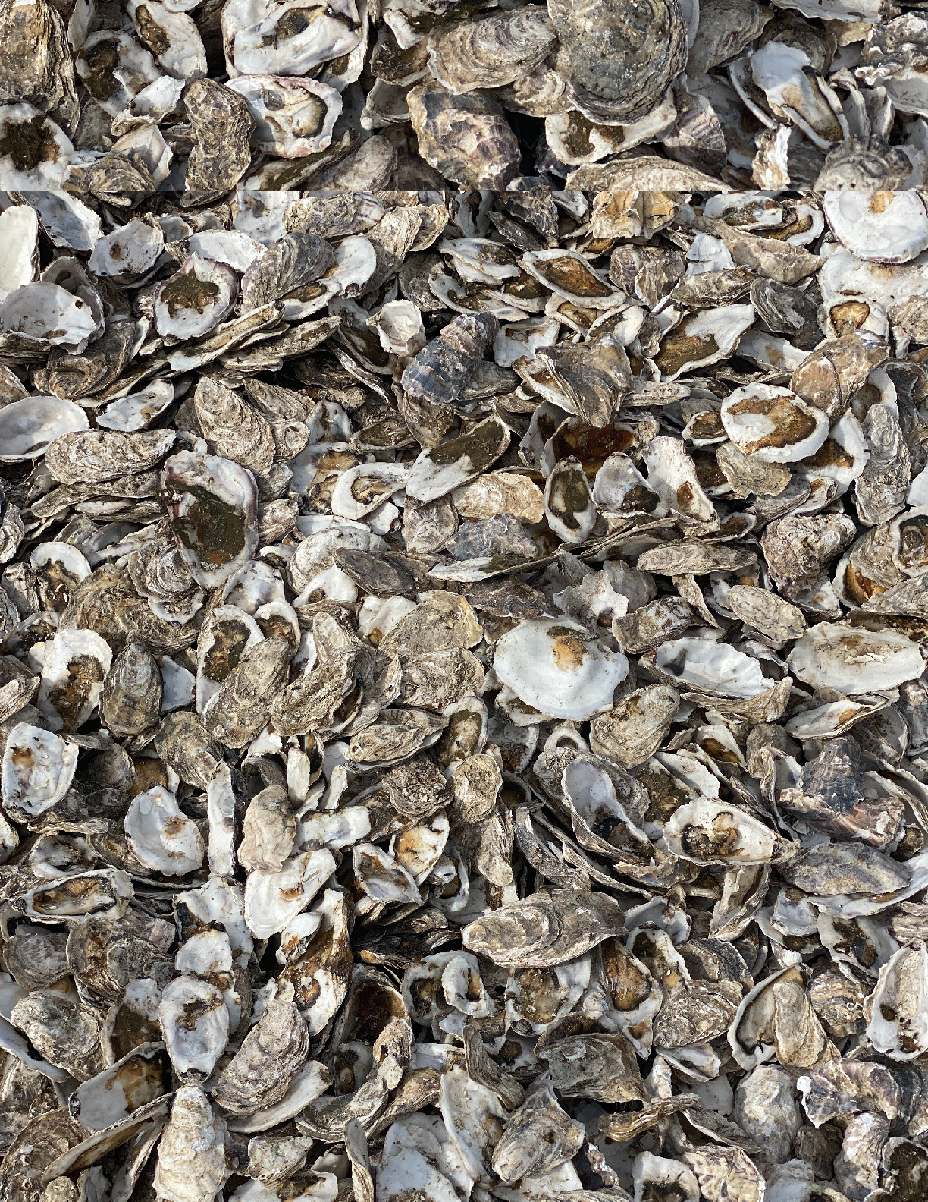
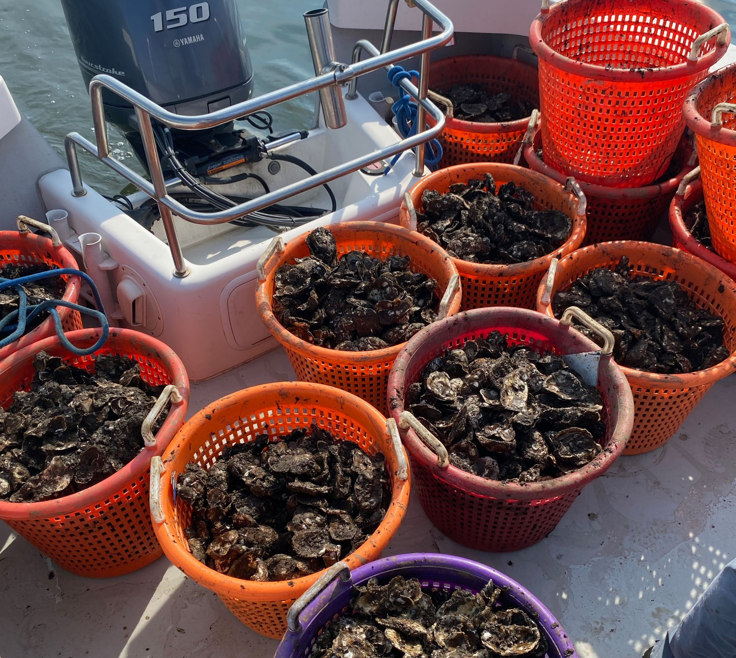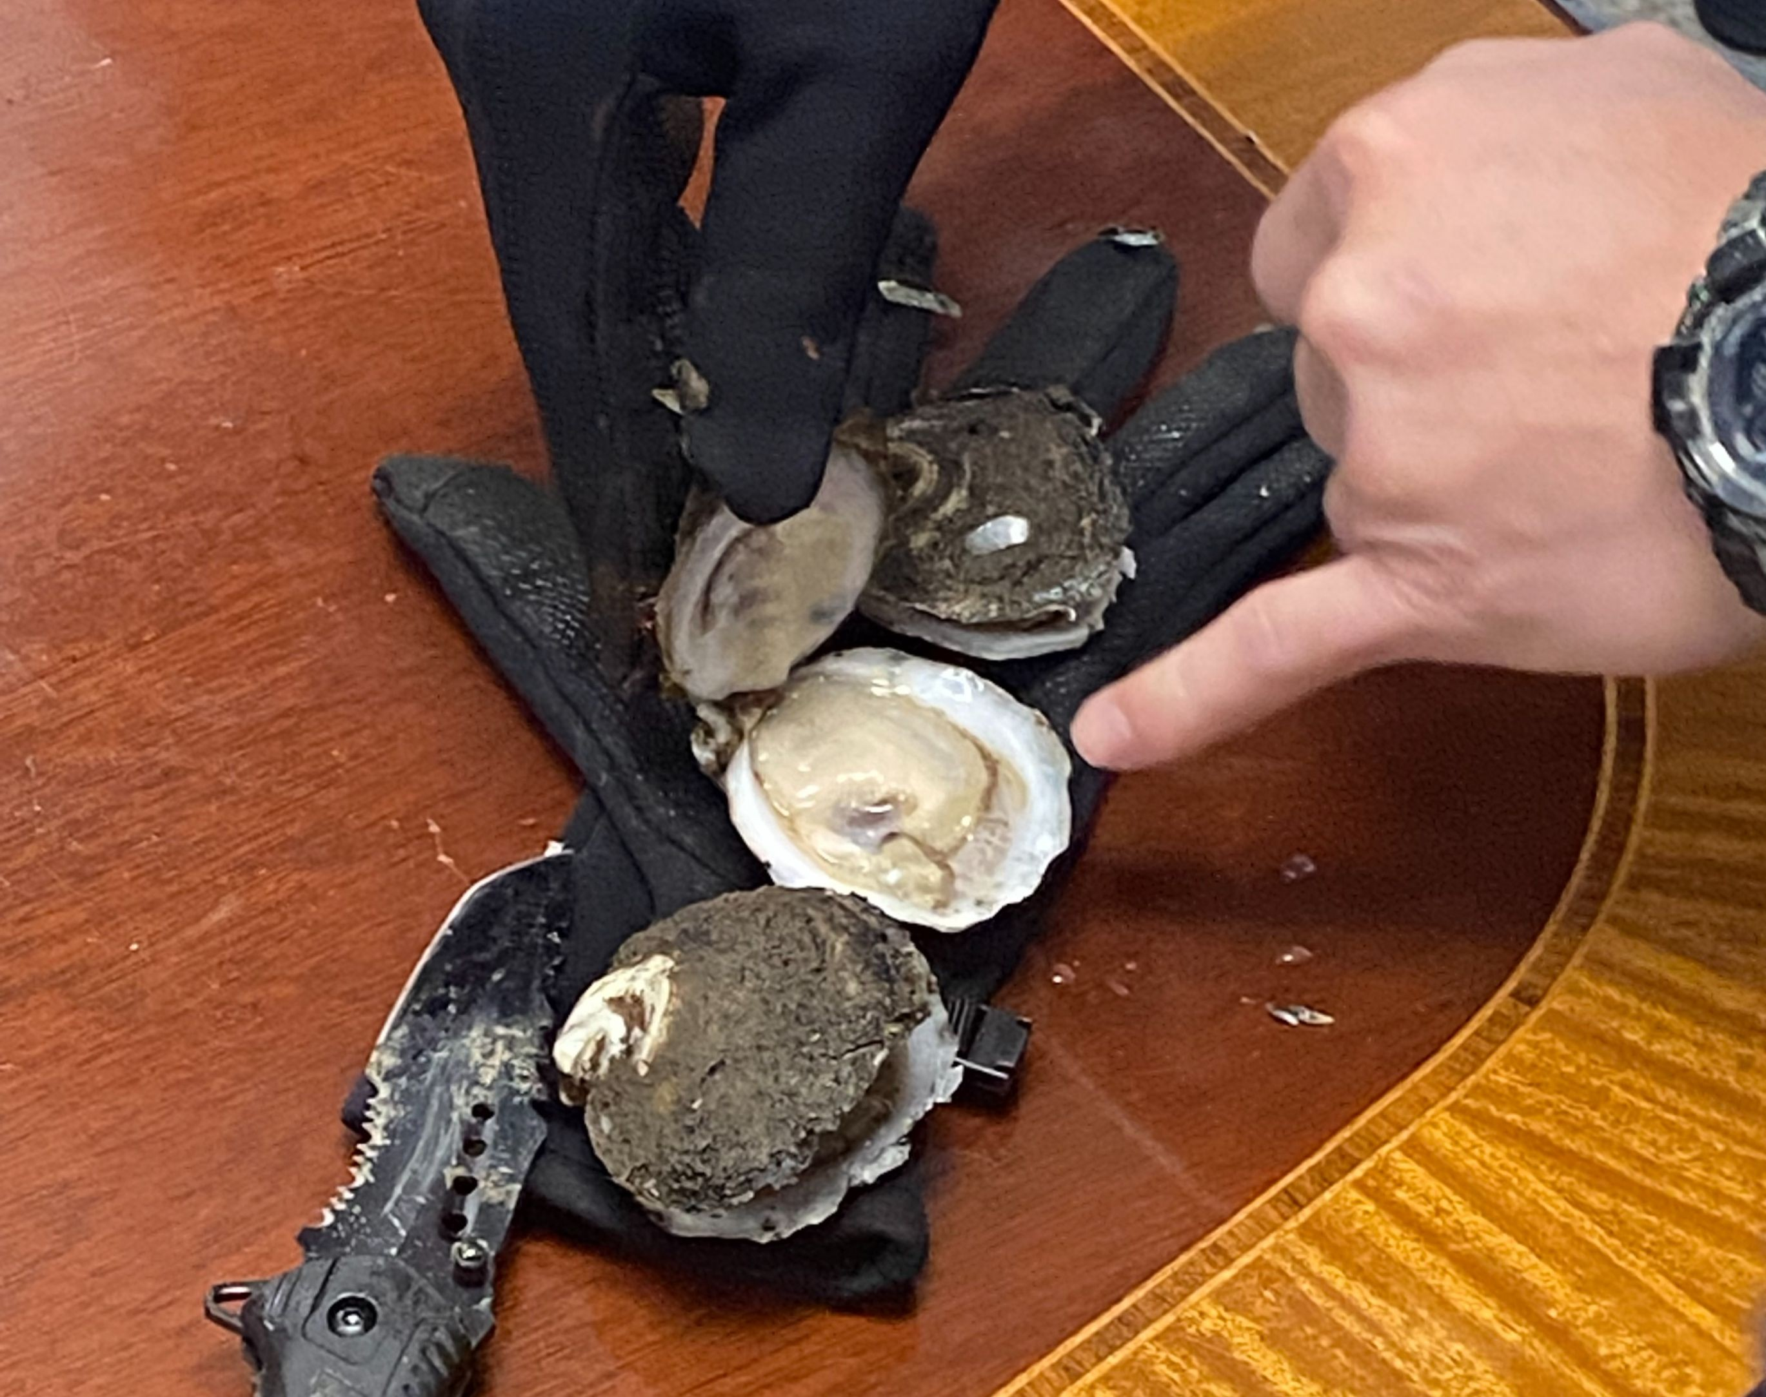

To learn more about our oyster growth, read UMBC graduate student Darryl Acker- Carter’s master’s thesis on the performance of SOPS from 2021 – 2022 production season compared to oyster gardening production, and shell shape and condition.

Restoration vs. Consumption
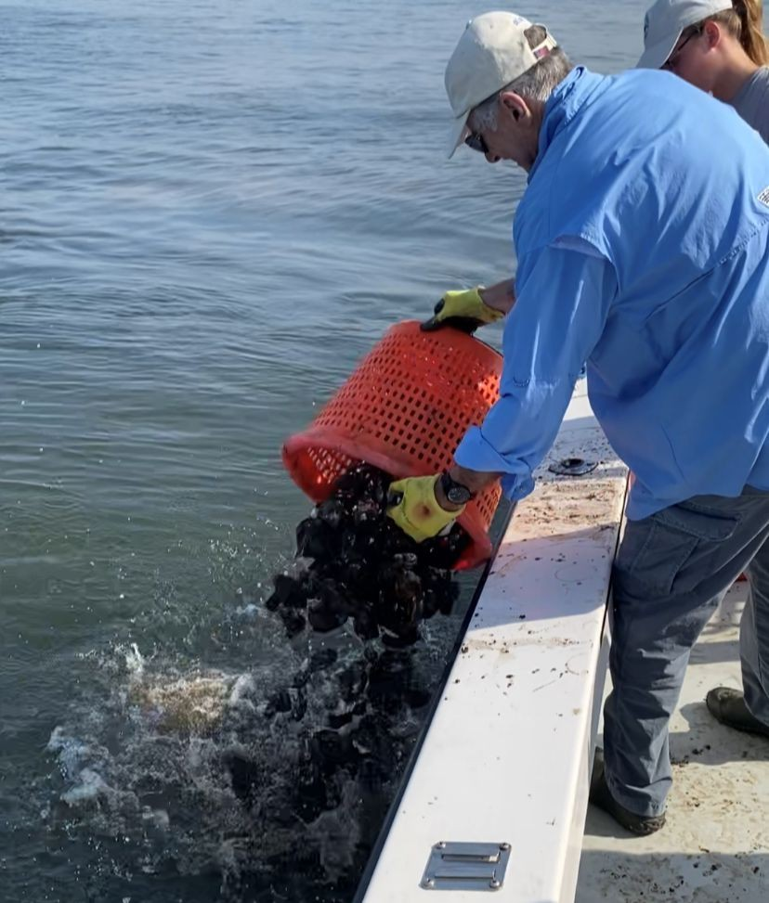
To date, most of the oysters grown by Solar Oysters have been for restoration. They have helped test and prove our SOPS technology while also rebuilding and enhancing the oyster population in Baltimore Harbor. In coordination with the Chesapeake Bay Foundation, and with support from the Abell Foundation, Solar Oysters has out planted an estimated 400,000 oysters on an oyster reef near Fort Carroll. With our success in growing oysters for restoration in Baltimore Harbor we are now ready to use SOPS to grow oysters for market.

This past Fall, the SOPS moved from the Baltimore Harbor to leasing grounds in the Chesapeake Bay near Fishing Bay, MD. In 2024 the SOPS prototype will grow triploid seed oysters. These oysters will be grown for market. Lessons learned from operating on an active oyster aquaculture lease will prepare SOPS for commercialization in 2025.

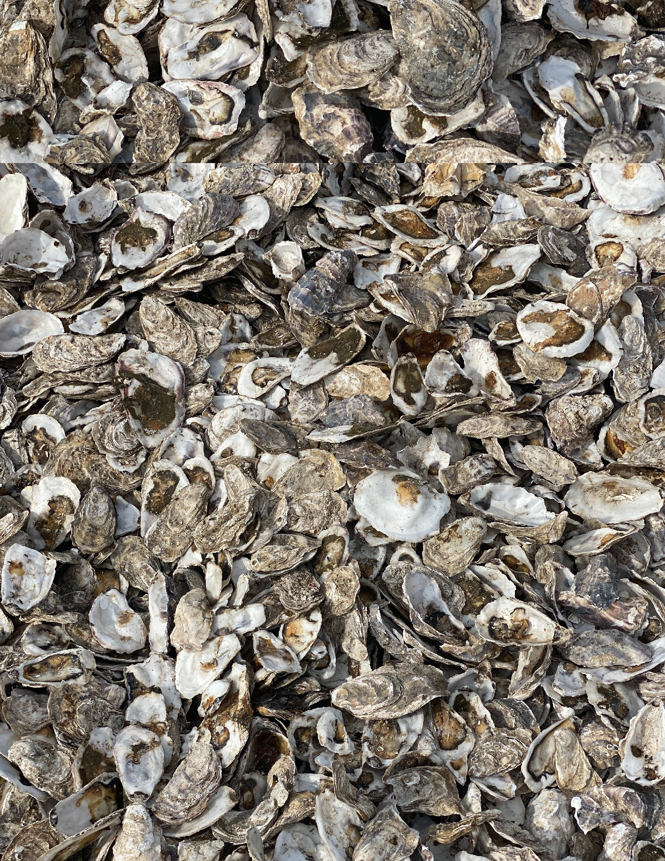
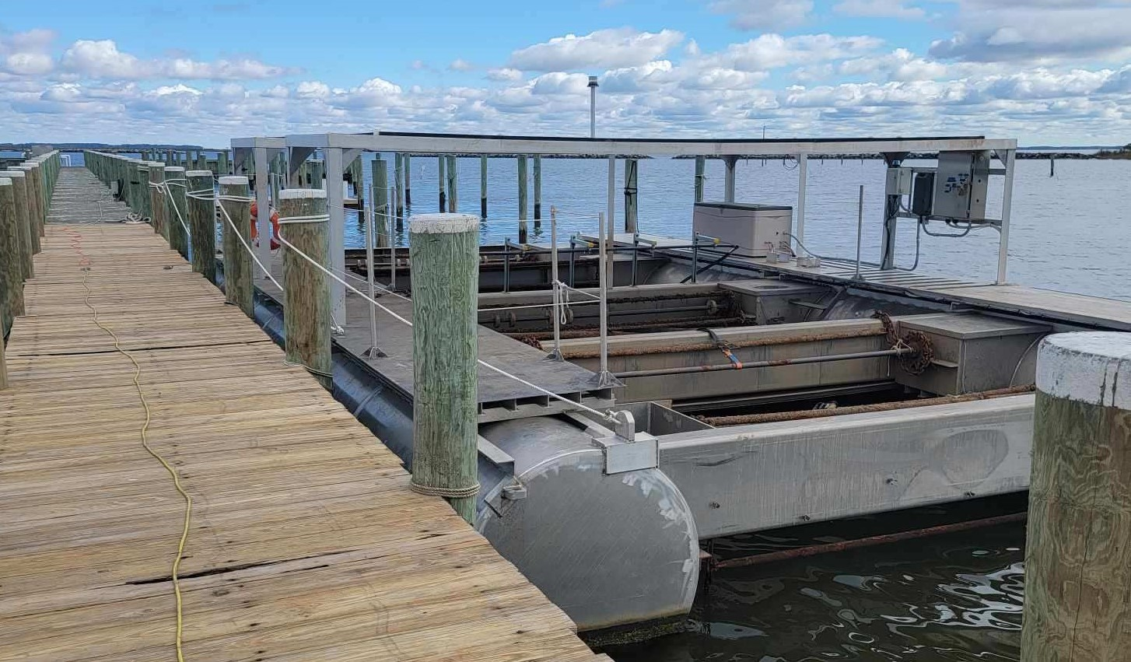
Fishing Bay, MD

Spray Wash System Tested
With support from the Chesapeake Oyster Innovation Award Program, Solar Oysters was able to construct an automatic spray wash bar system. The system is mounted overtop a ladder system to remove biofoul (e.g. macroalgae and barnacles) from oyster cages and the oysters themselves. When the spray wash system is turned on, the ladder will complete a full cycle to clean cages in a matter of minutes as opposed to the labor-intensive handheld pressure washing system. We look forward to continue to develop similar labor-saving components.
